Angular HANDS-ON 1: Environment Setup, Project Structure & First Component

Objective: To set up the Angular development environment, create a new Angular project, understand the project structure, generate components using Angular CLI, and display the Student Course Portal homepage successfully.

Commands Executed
npm install -g @angular/cli
ng new student-course-portal --routing --style=css
cd student-course-portal
ng serve
ng build
ng generate component components/header
ng generate component pages/home
ng generate component pages/course-list
ng generate component pages/student-profile

output-1
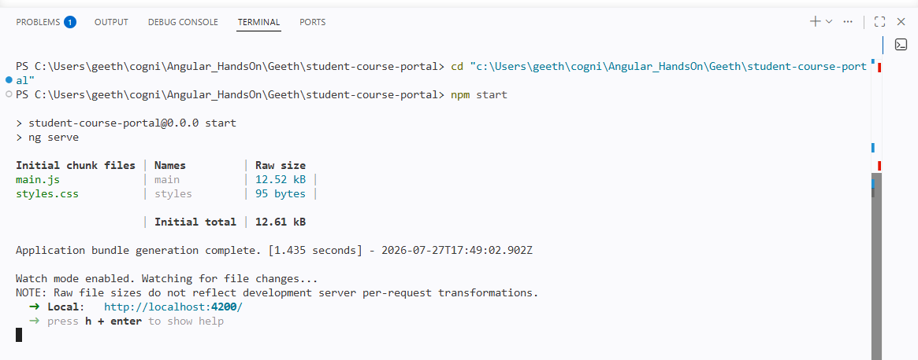

Output-2
